|  |  |
| --- | --- |
|  | **Wireless Sensors Networks tud_logo** |
|  | Project: Save The Plant ! WS2013-14 |
|  |  |
|  |  |
|  | Platz für eine Subheadline – 1 oder auch mehrzeilig - Platz für eine Subheadline –wenn andere Hintergrundfarbe dann Schriftfarbe ändern! |
|  |  |



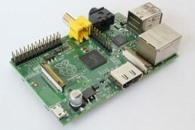

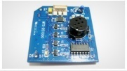

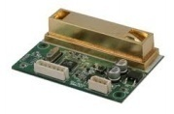

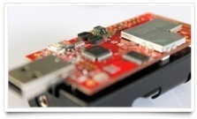

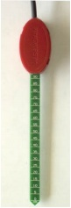

 

|  |
| --- |
| **Submitted By:**  Arjun Maryankandy Rajendran  **Project Guide:**  Eugen Berlin  Konstantin März  Mohammed Refat Chowdhury  Pratyush Agnihotri  Rick Nitsche |

 

**Abstract**

It’s a thing of massive gratification for us to present this Project Report on the project- “Save the Plant!”.

Information Technology adoption is on the rise and recent technological innovation have dramatically enhanced the capability of the organization performance leveraging the power of these technologies , various business sectors are working together to offer a wide array of  services internal as well as external to the organization.

The project is basically an implementation to degrade the greenhouse effect on plant using Wireless Sensors Networks. Concentration of greenhouse gases increased quickly since 1750. In result, gases like CO2 and CO increase with higher rate which is not a good sign for plants. This will cause adverse effect on plants such as requires more water, some plants reduce their ability to do photosynthesis, plants become more vulnerable to insects, pests, and diseases

A **Wireless Sensor Networks,** is a system of sensor nodes that captures, stores, analyzes, manages, and presents data that are linked to location. It provides user with better and more efficient means of managing, monitoring, utilization of resources and keeping a record to maintain the ideal condition for plants. Our solution, monitor the system, take samples in every five seconds, on the basis of threshold value, decision is sent to sink node to manage actuators so that plant ideal condition can be sustain.

This project has several advantages and it could be of immense help as it can monitor over a specific area without actually being there physically. Also it is capable of providing statistics which assist us in looking the change in respective areas over a period of time and also predicting over future trends.

Like any other application, this project has a great scope of evolving in the future. The application can be converted into “Land Monitoring System” which will include, web based interface, **desktop widget** which will show the current status of the land resources on the desktop to prevent frequent login. Also a **mobile version** of the application is proposed which would run on Windows/Mac Mobile platform which would enhance the portability as well as flexibility.

**Acknowledgement**

Presenting a “Wireless Sensors Networks Lab” project of this type is an arduous task, demanding a lot of time. We cannot in full measure reciprocate the kindness shown and contribution made by various persons in this endeavour. We will remember all of them with gratitude.

Our sincere thanks towards **Mr. Eugen Berlin** (Project Guide), for giving us a chance to take this project and for his valuable guidance, which helped us on all those points, which we needed to include in, with full intensity, for his significant support extended for the successful completion of the project.

We are extremely gratified to **Mr. Pablo Ezequiel Guerrero** and **Mr. Iliya Gurov**, who were extremely helpful in offering their professional expertise and bestowing our practical knowledge in all the field which are required and related to this project.

We are always beholden to our God, for always being with us and showing our the right ways, my family members, for always doing favours to our and our friends and colleagues consistently helped with encouragement and criticism throughout the project work, for always lifting our sights to higher vision, raising our personality beyond normal limitation and for realizing us our strengths and potential.

**Contents**

|  |  |  |
| --- | --- | --- |
| * **Chapter- 1 : Introduction** |  |  |
| **1.1** Definition of Problem |  |  |
| **1.2** Goal |  |  |
|  |  |  |
| * **Chapter - 2 : Device/Driver Information & Plant Living Condition** |  |  |
| **2.**1 Device /Driver Information |  |  |
| **2.2** Plant Living Conditions |  |  |
|  |  |  |
| * **Chapter - 3 : Soldering of Sensor** |  |  |
| **3.**1 Xm1000 pin Structure |  |  |
| **3.**2 Soldering Moisture Sensor |  |  |
| **3.3** Soldering CO2 Sensor |  |  |
|  |  |  |
| * **Chapter – 4 : Test Bed Setup** |  |  |
| **4.**1 Given Step up |  |  |
| **4.**2 Proposed Step up |  |  |
| **4.3** Current Step up |  |  |
|  |  |  |
| * **Chapter – 5 : Formulas for Calculation** |  |  |
| **5.**1 Formulas for Light |  |  |
| **5.**2 Formulas for Temperature |  |  |
| **5.**3 Formulas for Humidity |  |  |
| **5.**4 Formulas for Soil Moisture |  |  |
| **5.5** Formulas for CO2 |  |  |
|  |  |  |
| * **Chapter – 6 : Usage of Actuator** |  |  |
| **6.**1 Actuator behavior of different condition |  |  |
|  |  |  |
| * **Chapter – 7: Functioning of Application** |  |  |
| **7.**1 Functioning of Application |  |  |
|  |  |  |
| * **Chapter – 8: Sampling & Visualization** |  |  |
| **8.**1 Sampling & Visualization |  |  |
|  |  |  |
| * **Chapter – 9: Testing & Code Optimization** |  |  |
| **9.**1 Testing |  |  |
| **9.**2 Code optimization |  |  |
|  |  |  |
| * **Chapter – 10: Challenges** |  |  |
| **10.**1 Challenges |  |  |
|  |  |  |
| * **Chapter – 11: Advantages and Disadvantages** |  |  |
| **11.**1 Advantages of System |  |  |
| **11.**2 Disadvantages of System |  |  |

**Chapter 1 -: Introduction**

**1.1 Definition of Problem**:

* Learn about living conditions for known plants :
  + Peperomia(Radiator Plant)

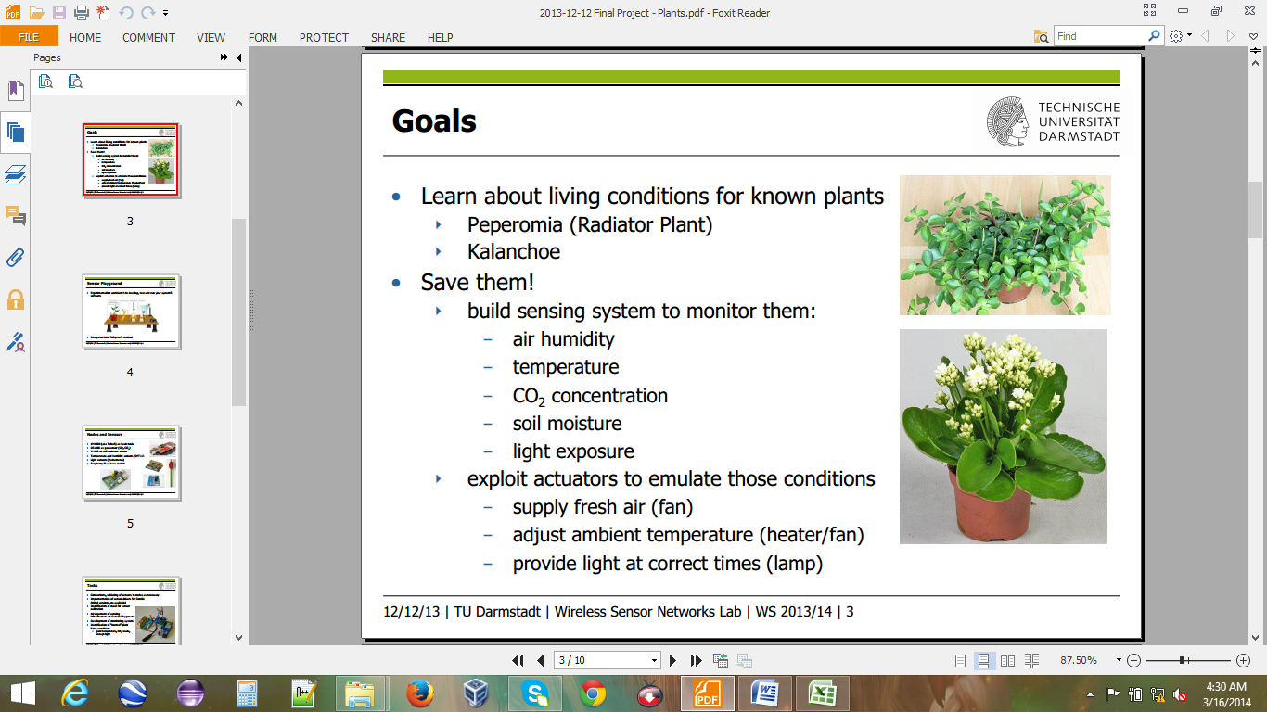

* + Kalanchoe



* Build sensing system to monitor them:
  + air humidity
  + temperature
  + CO2 concentration
  + soil moisture
  + light exposure
* Exploit actuators to emulate those conditions
  + supply fresh air (fan)
  + adjust ambient temperature (heater/fan)
  + provide light at correct times (lamp)

**1.2 Goal**:

* Provide monitoring system
* Save the Plant

**Chapter - 2 : Device/ Driver Information & Plant Living Condition**

**2.1 Device /Driver Information**:

|  |  |  |  |
| --- | --- | --- | --- |
| **Category** | **Device Name** | **Driver Name** | **Device Image** |
| Basic Node : | • XM1000 (aka TelosB) as basic node |  |  |
| On Board Sensors: | •  Light sensors (Hamamatsu) | dev/light-sensor.h | File:S1087.jpg |
|  | •  Temperature and humidity sensors (SHT11) | dev/sht11-sensor.h | http://www.sensirion.com/typo3temp/pics/13519f94b7.jpg |
| Co2 Sensor : | •  DS1000 as gas sensor (CO, CO2 ) | ds1000-sensor.h |  |
| Soil Moisture Sensor : | •  VH400 as soil moisture sensor | vh400.h |  |
| Base Station : | •  Raspberry Pi as base station |  | Raspberry Pi model A |

**2.2 Plant Living Conditions**:

|  |  |  |
| --- | --- | --- |
| **Conditions** | **Peperomia(Radiator Plant)** | * **Kalanchoe** |
| **Air humidity** | * Love warm humid conditions | * Plenty of air flow around plant material.   **Problem:** Powdery mildew is another possible disease problem for Kalanchoe. Powdery mildew can be difficult to recognize on Kalanchoe because only fine webbing will develop. |
| **CO2 concentration** | * 40 ppm or 950 ppm CO2 | * 40 ppm or 950 ppm CO2 |
| **Temperature** | * Minimal temperature: 13-15°C (55-59°F) * Optimal temperature: 24-28°C (75-82°F) | * During Night = 45-65 °F (7.2 - 18.3)ºC * During Day = 50-70 °F (10- 21)C * Cool night temperatures prolong flower life   **Note:** They prefer warmth. Do not let fall below 55ºF. (12.7778 ºC) |
| **Soil moisture** | * humus-peat-loosely * avoiding wetting the crown of the plant * Soil Range: Sandy Loam to Loam * Water range : Normal to Normal * avoiding wetting the crown of the plant | * Can be damaged by over watering * Allow the soil to dry slightly between watering   **Note:** Water moderately throughout the summer and reduce watering in the winter. Let the soil surface dry out between watering, and in the winter, the plant can almost dry out. Watch the fleshy leaves for signs of water distress. |
| **Light exposure** | * bright and mid-shade * best cultivated in a light | * Full sun and a well-drained potting media * Tolerate bright indoor light levels well * Plants tend to get spindly in low light conditions. * 14 to 16 hours each day to block all light |

**Chapter - 3 : Soldering of Sensors**

**3.1 Xm1000 pin Structure**:



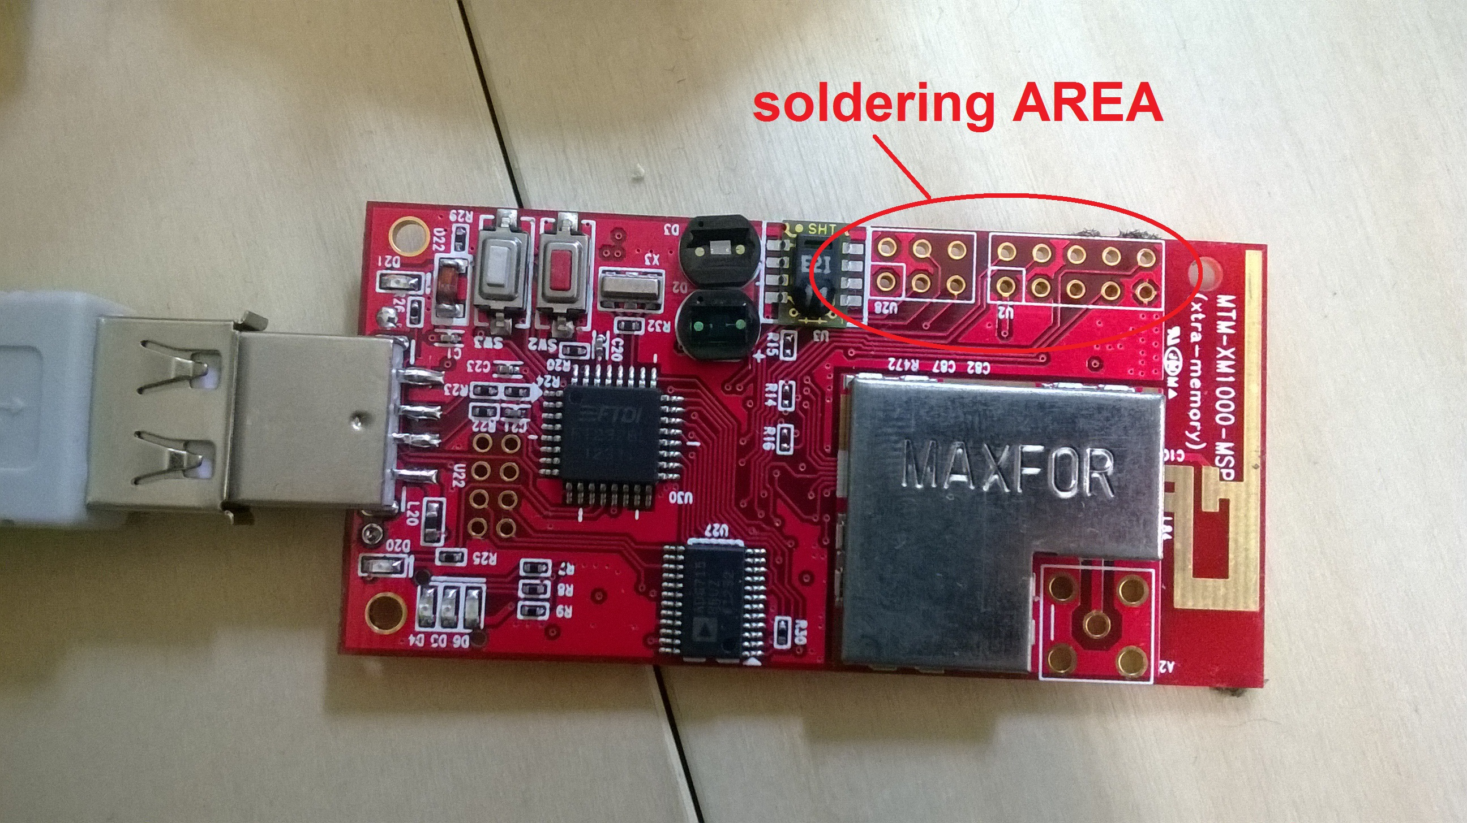

The XM1000 includes an expansion connector that allows the access to a number of pins in the microcontroller.

**3.2 Soldering Moisture Sensor**:

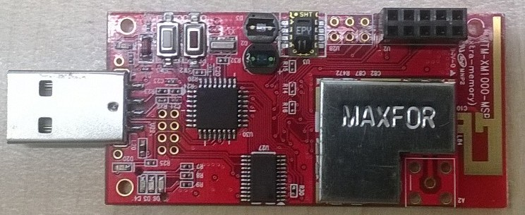

**Steps for Soldering moisture sensor:**

1. ADC pin are soldered in Xm1000 nodes (Operational Amplifiers Array (LM324).
2. Soil moisture wires (Bare, Red and Black wire) are soldered with pin connector.

### Soil Moisture Sensor Probe Wiring Table :

|  |  |
| --- | --- |
| Bare | Ground (PIN 9 : GND) |
| Red | POWER:  3.3V to 20 VDC. (PIN 1: DVCC) |
| Black | OUT: (0 to 3V ) ( PIN 7 : ADC 2) |

1. Soil Moisture sensor is connected to xm1000 nodes in following order :

|  |  |
| --- | --- |
| PIN 1 | Power |
| PIN 7 | Output |
| PIN 9 | Ground |

1. Same steps are repeated with second soil moisture.
2. Testing through multimeter (Volt-Ohm meter) to check the proper voltage supply and wire connection.

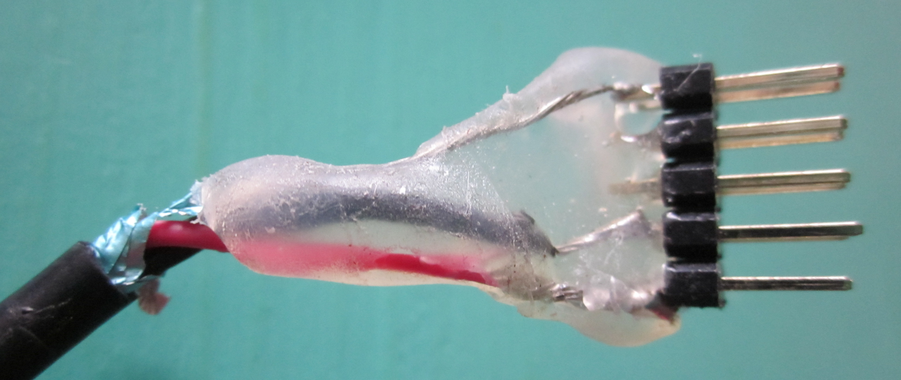

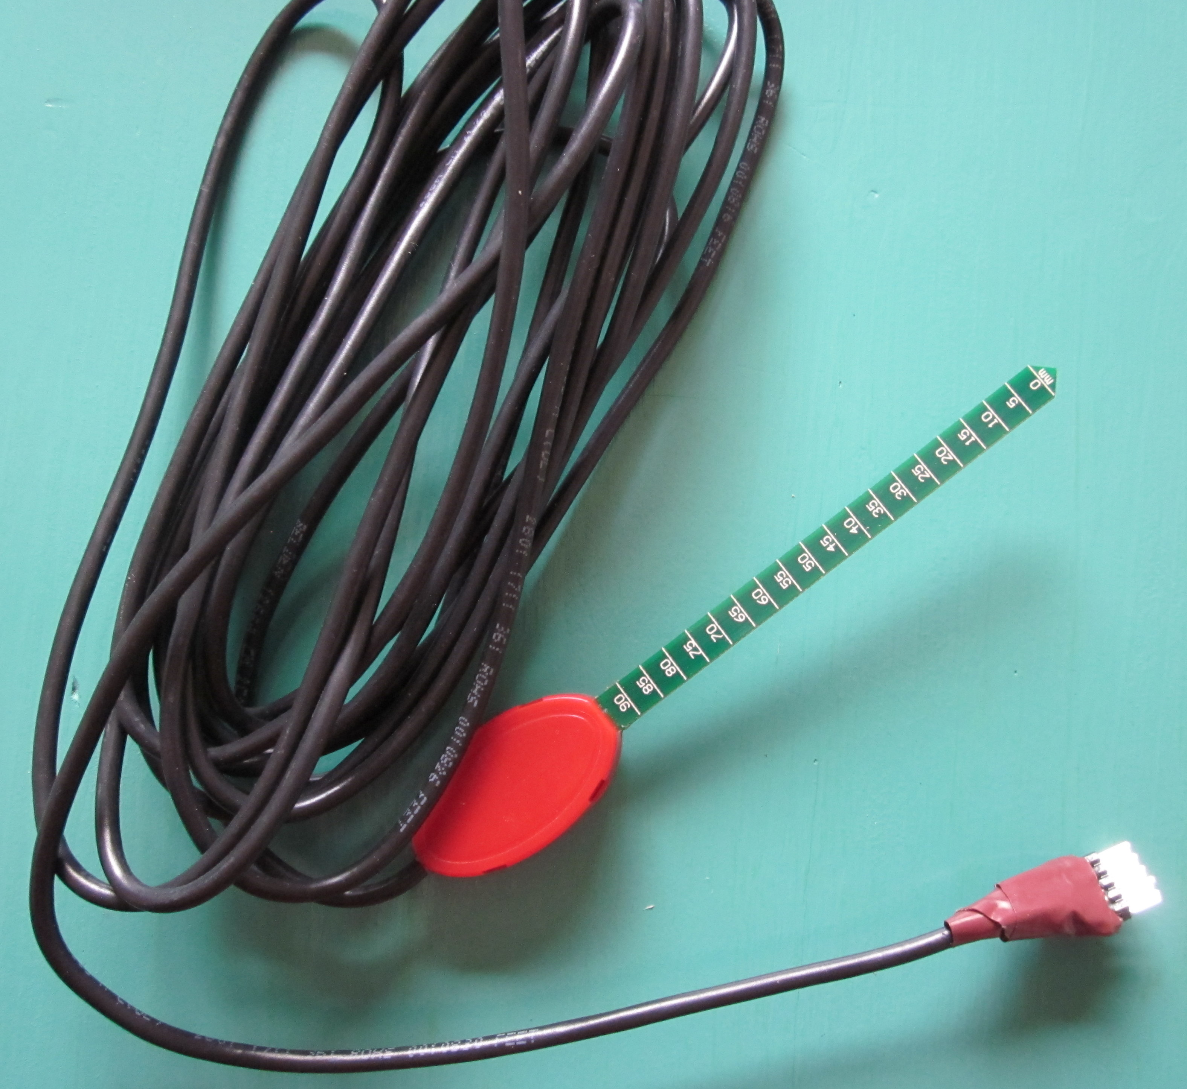

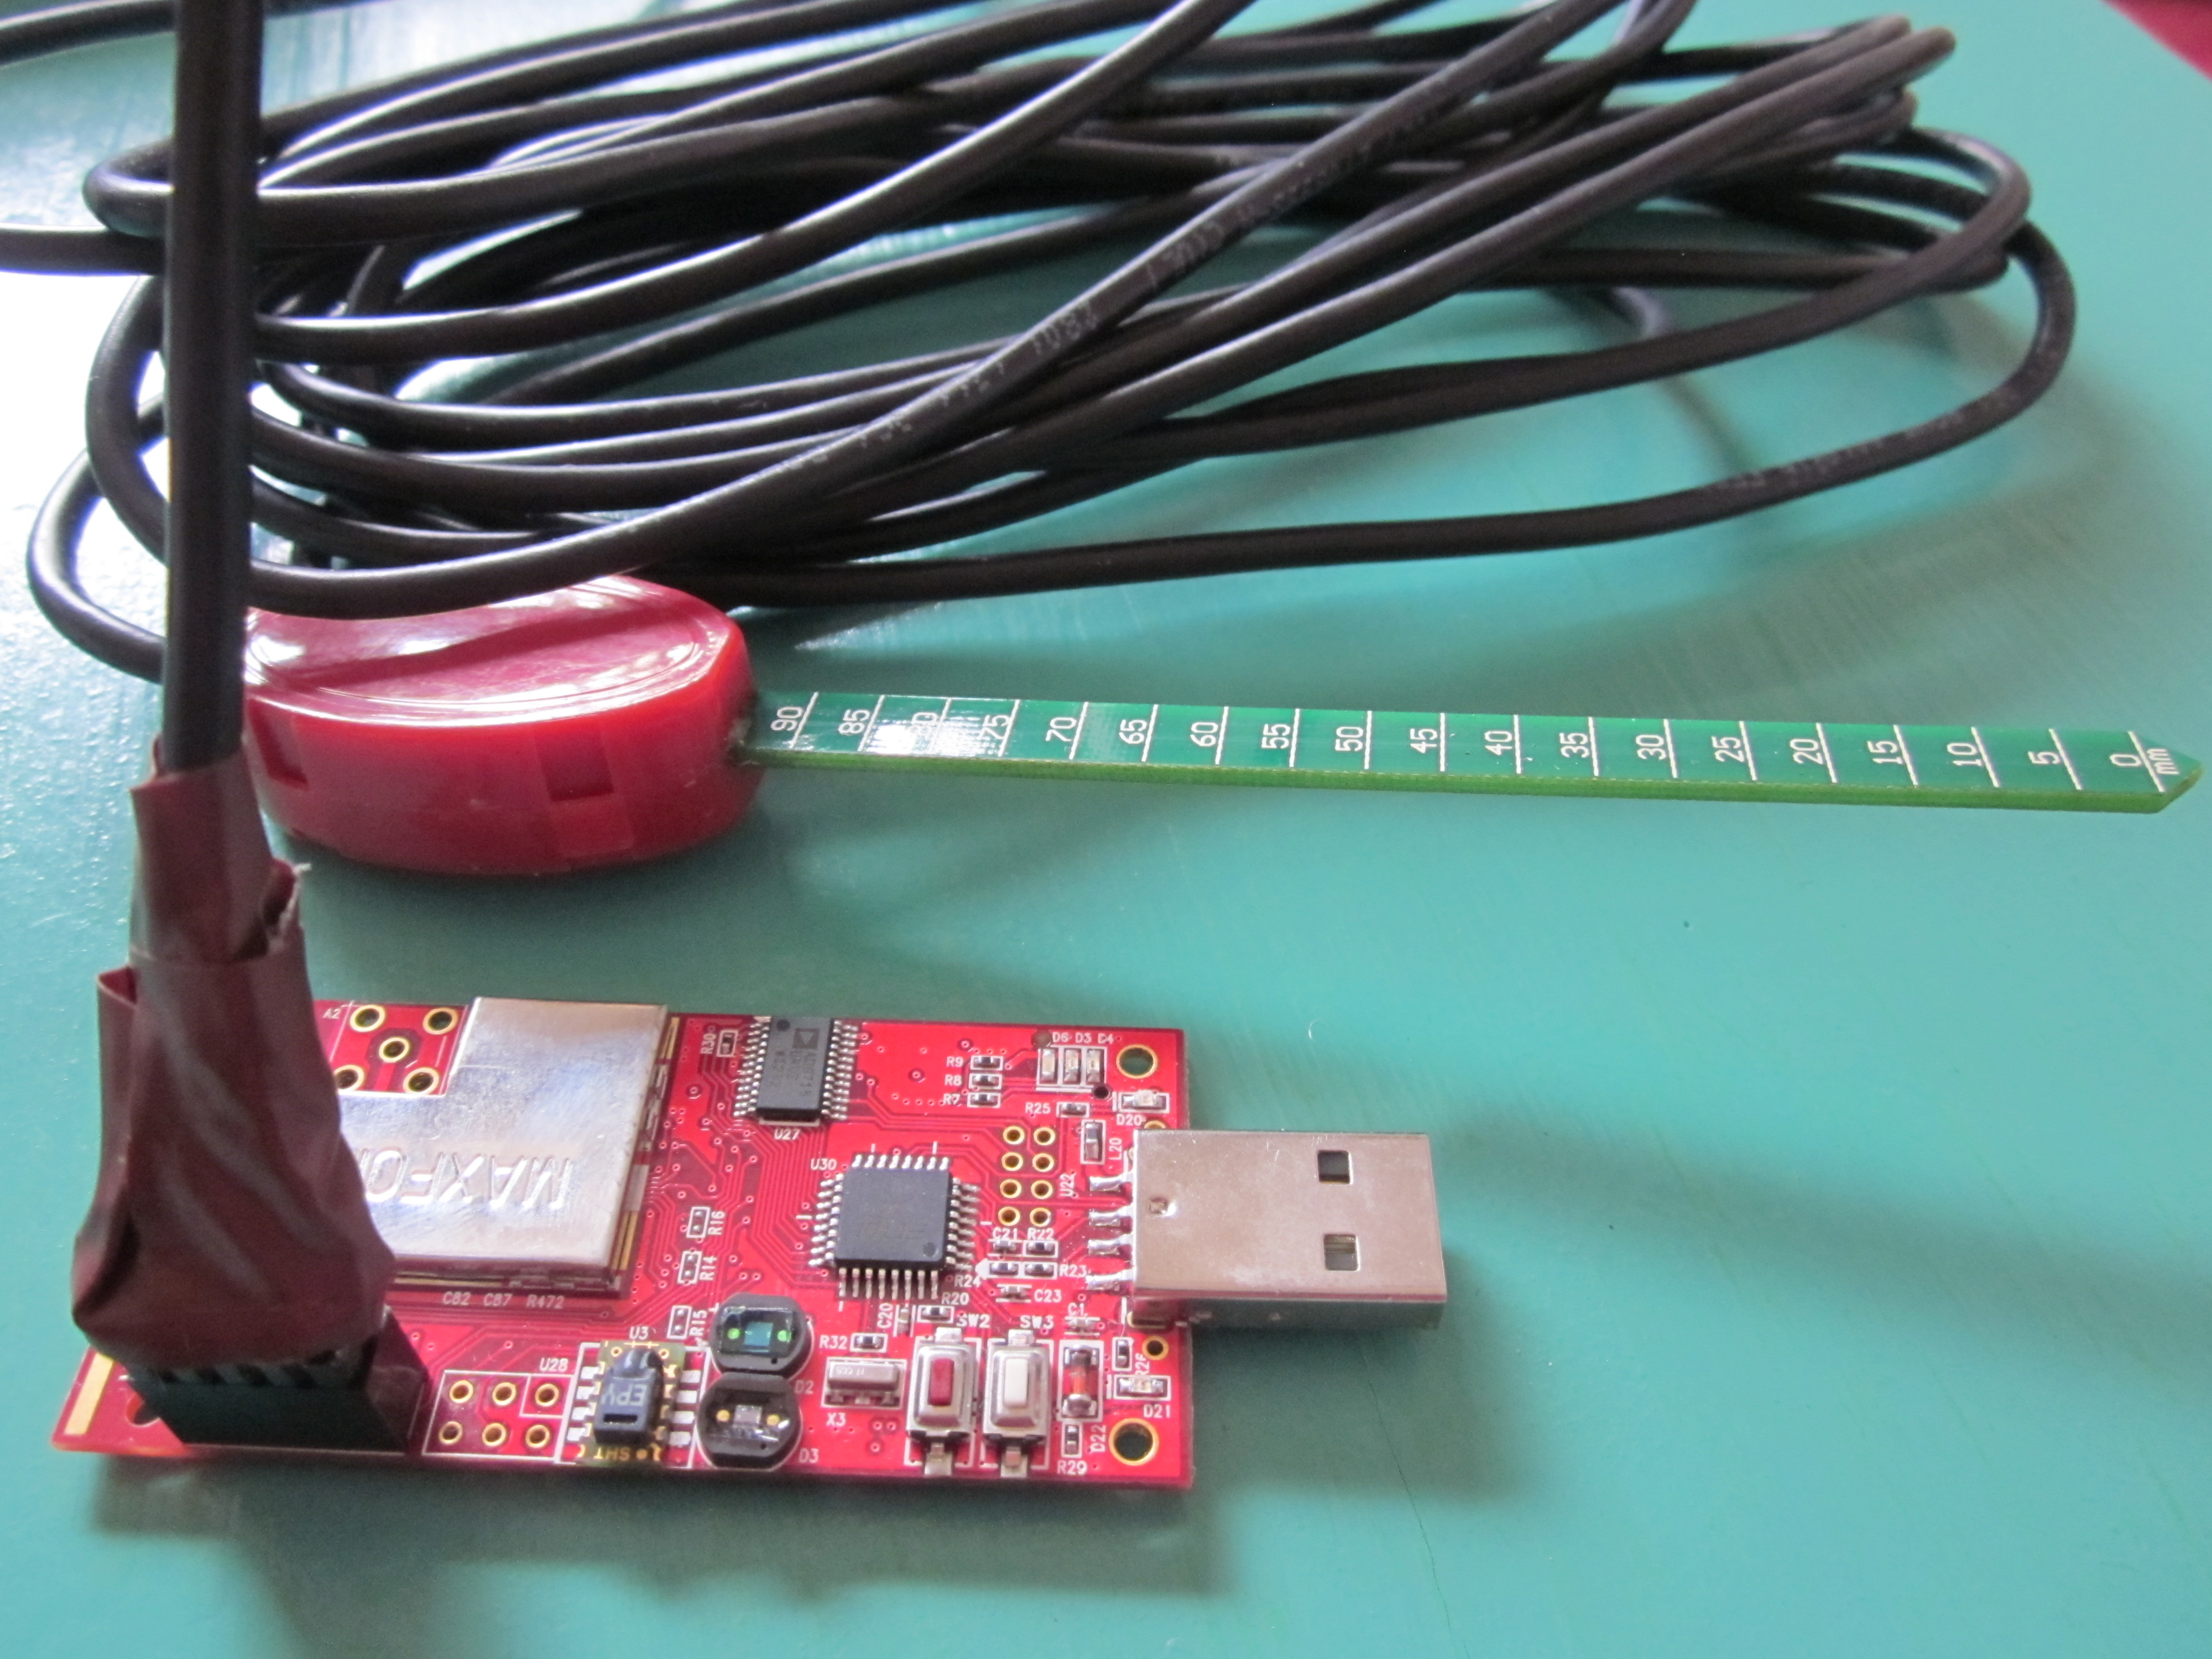

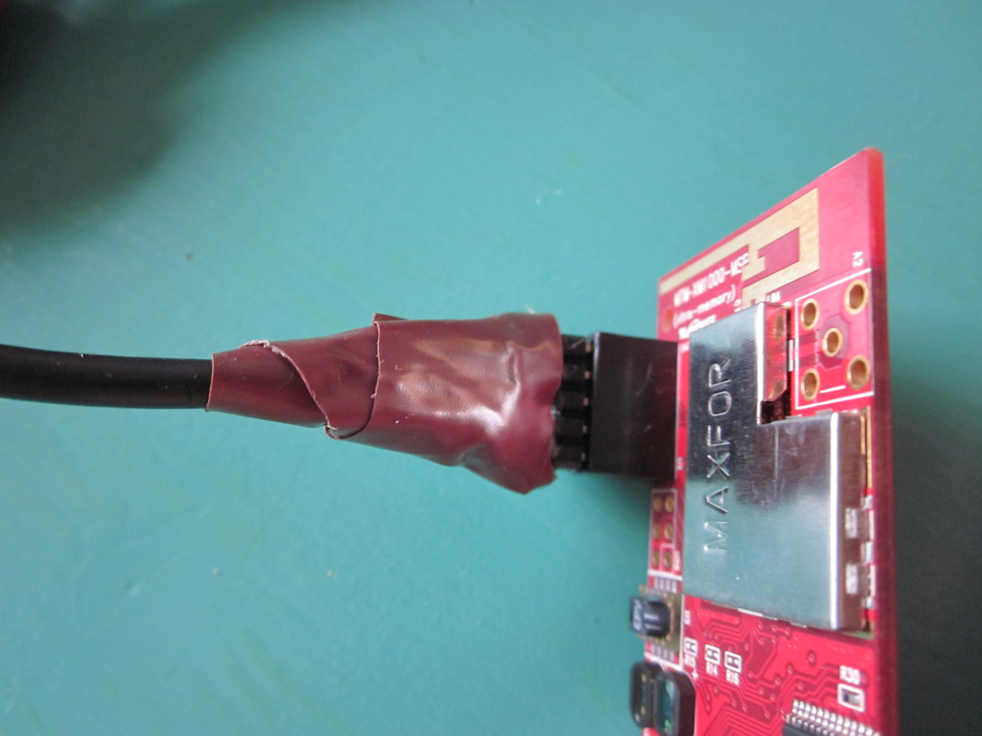



**3.3 Soldering CO2 Sensor**:

**Steps for Soldering CO2 sensor:**

1. ADC pin are soldered in Xm1000 nodes with Operational Amplifiers Array (LM324).
2. 51pin connector is soldered with both DS1000
3. Pcb –board and DS1000 attached with each other.
4. XM1000 , PCB-board and DS1000 Sensor are attached.
5. DS1000 Board and SH-300-DC are connected using DC 9V adapter jack
6. DS1000 board, PCB-board, SH-300-DC and Xm1000 are attached together.

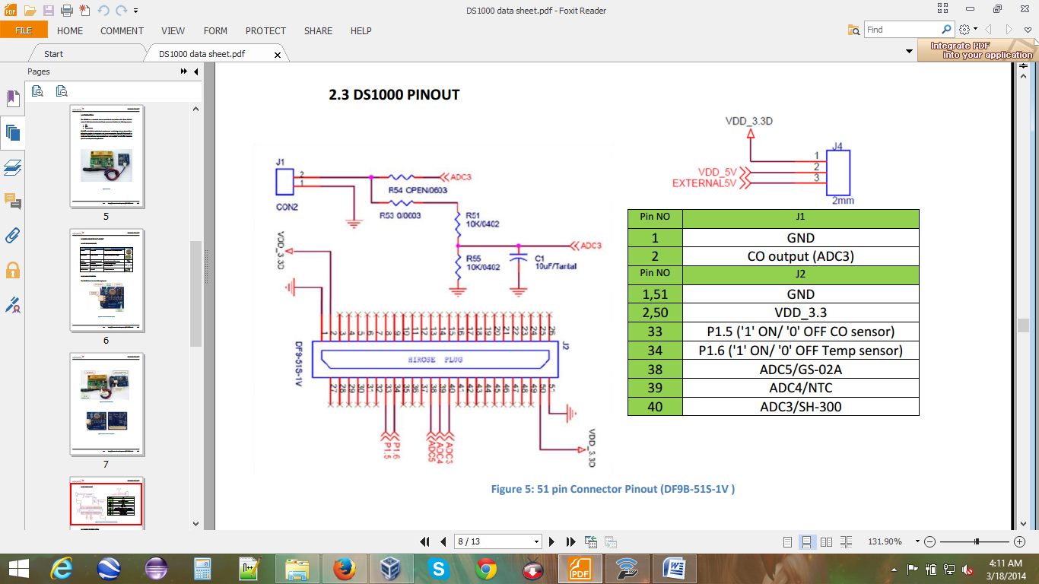

**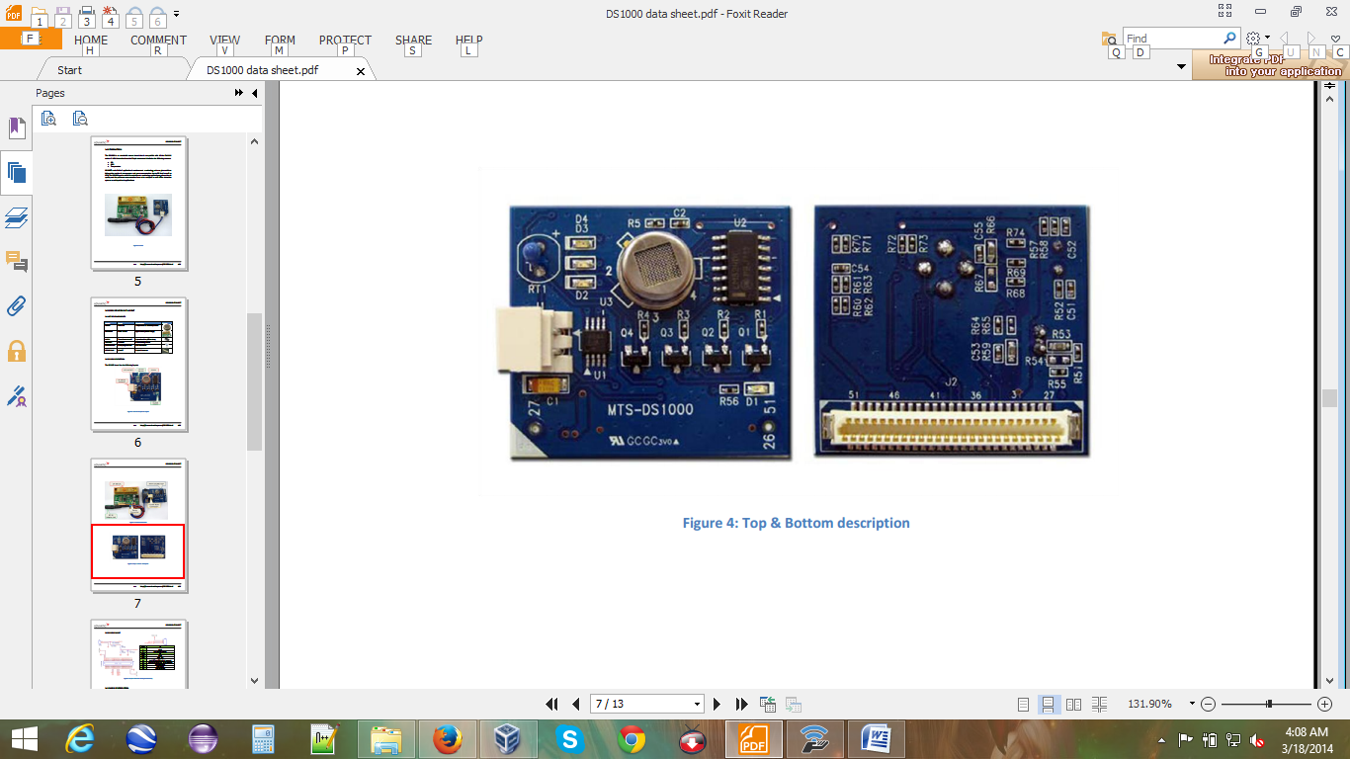**

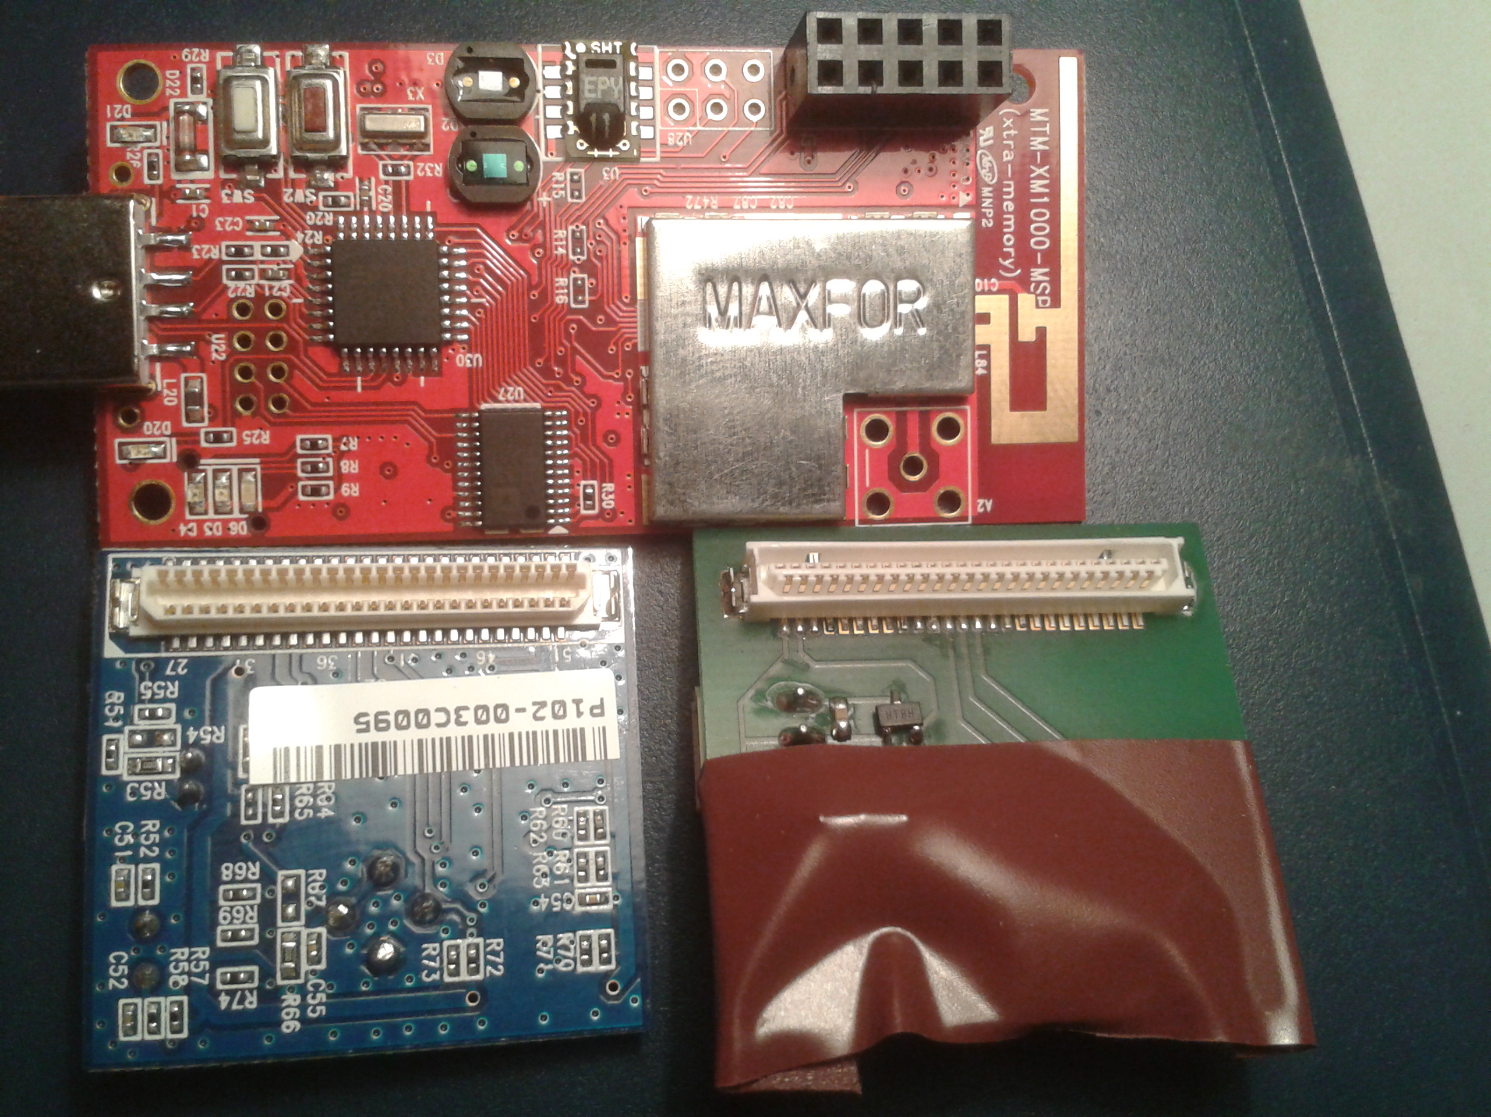

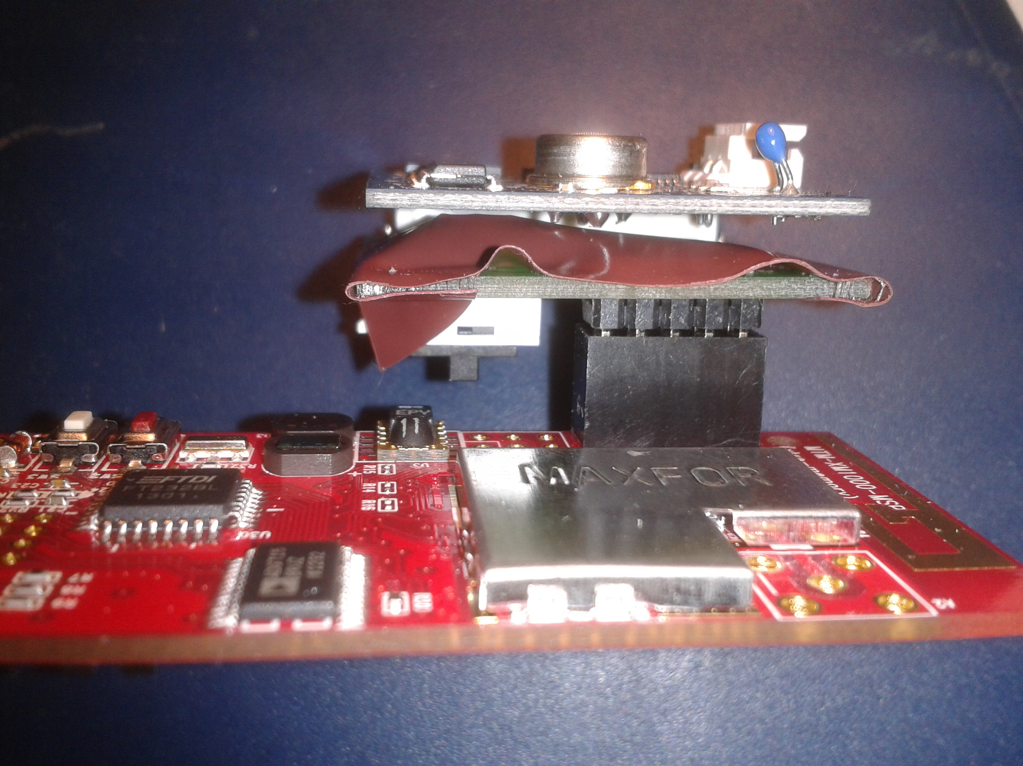

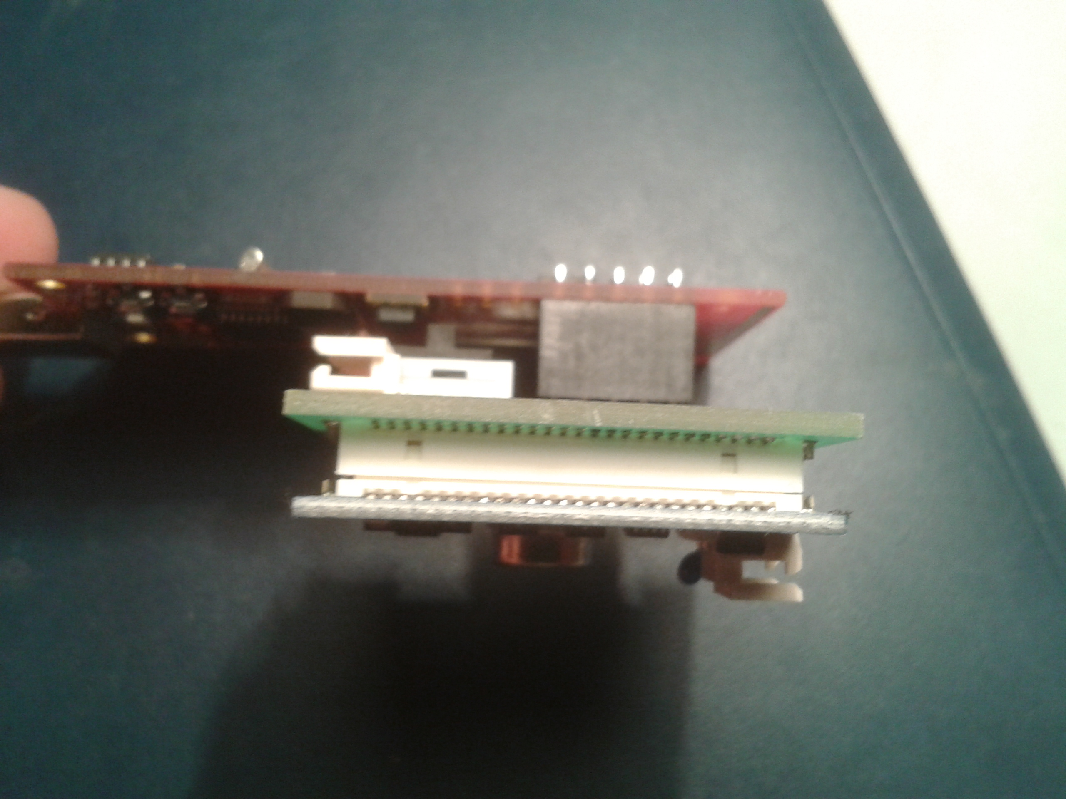

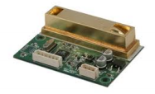

**Learning’s:**

1. How to do soldering.
2. There should not be any gap between connector and node/board while soldering.
3. While soldering, soldering part should be covered. There should not be any lose connection.

**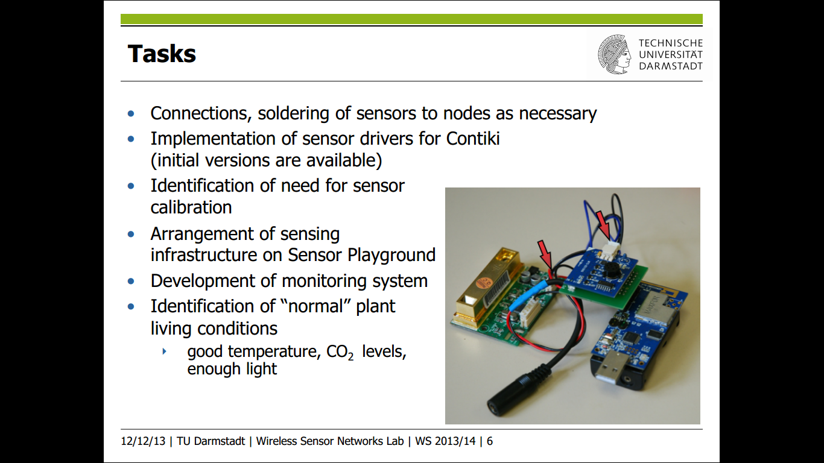**

**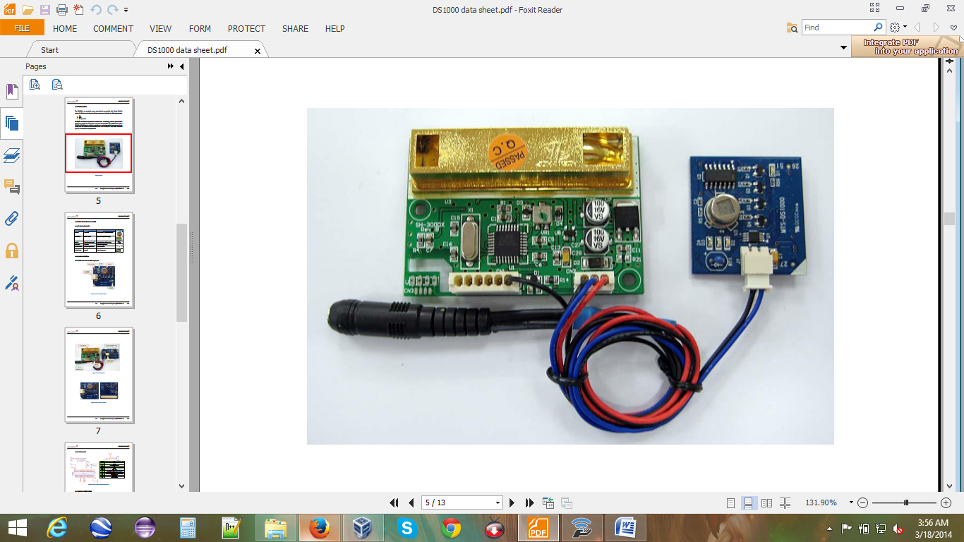**

**Chapter - 4 : Test Bed Setup**

**4.1 Given Step up**:

**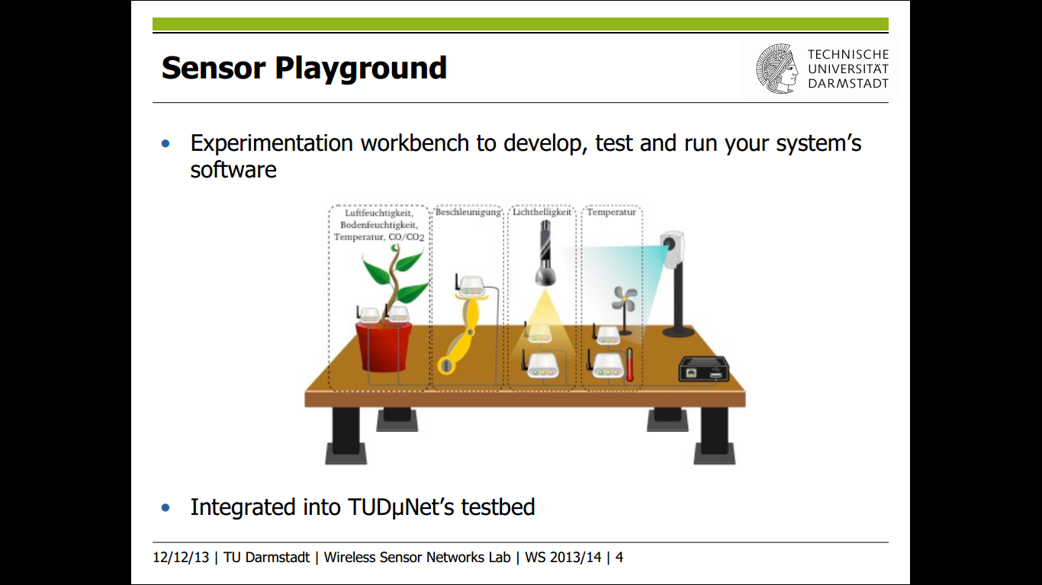**

**4.2 Proposed Step up:**

Right Plant : Peperomia

Left Plant: Kalanchoe

USB LIGHT R

USB LIGHT L

sink

USB FAN R

USB Heater R

USB FAN L

USB Heater L

**STEP 1:**

1. On board Sensor (light, humidity and temperature), Co2 and Moisture sensor (both left and right) will collect a values and do sampling.
2. If value is below /Ok/ high than threshold value then send command to sink.

L = Left plant

R= Right plant

USB LIGHT L

Right Plant: Peperomia

Left Plant: Kalanchoe

USB Heater R

USB Heater L

sink

USB LIGHT R

USB FAN R

USB FAN L

**STEP 2:**

1. When commands will be received by sink , it will send ON/OFF action to corresponding actuators :

FAN: CO2 (HIGH / OK)

LIGHT: LIGHT (LOW / OK)

HEATER: MOISTURE (HIGH / OK)

1. States are stored in the sink.
2. No action will be sent by sink until new command is received.

**4.3 Current Step up:**

1. [3009] On board Sensor (light, humidity and temperature), [3002] Co2 and [3007 and 3003] Moisture sensor (both left and right) will collect a values and do sampling.
2. If value is below /Ok/ high than threshold value then send command to sink 3001 and 3008.
3. When commands will be received by sink 3001 and 3008, it will send ON/OFF action to corresponding actuators :

FAN: CO2 (HIGH / OK)

LIGHT: LIGHT (LOW / OK)

HEATER: MOISTURE (HIGH / OK)

1. States are stored in the sink 3001 and 300b for respective plants.
2. No action will be sent by sink until new command is received.

3001

3008

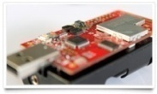

3003

3009

3002



3007

Commnad from 3002 to 3001 & 3008

Action ON/OFF to Light

Commnad from 3009 to 3001 & 3008

Action ON/OFF to Heater

Commnad from 3007 to 3001 & 3003 to 3008

Action ON/OFF to Fan

|  |  |  |  |
| --- | --- | --- | --- |
| ****Serial No.**** | Node Type | Node ID | Position |
| **FTWU3V1Q** | Sink Node | ID 3001 | RIGHT |
| **FTWGX4RJ** | CO2 Sensor | ID 3002 | RIGHT |
| **FTWU3VN7** | Soil Moisture Sensor | ID 3003 | RIGHT |
| **FTWG8BJM** | Soil Moisture Sensor | ID 3007 | LEFT |
| **FTWGX4YY** | Sink Node | ID 3008 | LEFT |
| **FTWGX5V2** | Onboard sensors | ID 3009 | LEFT |

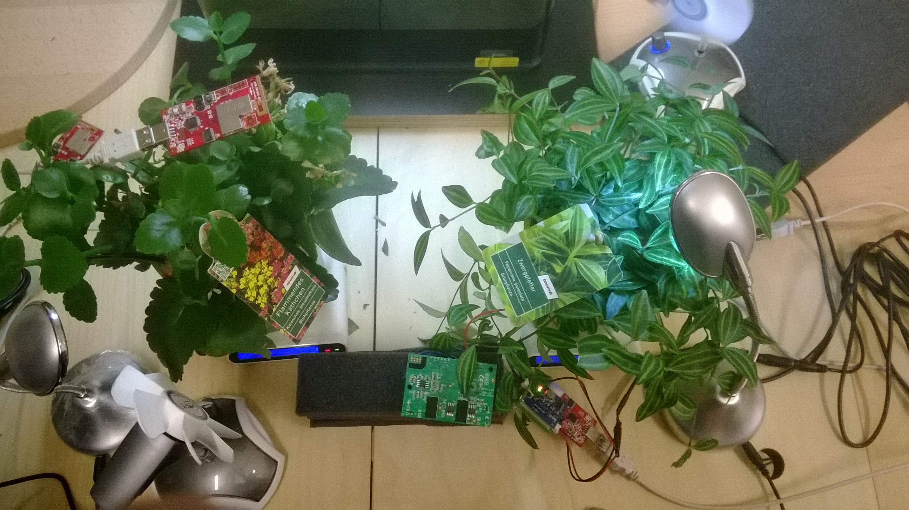

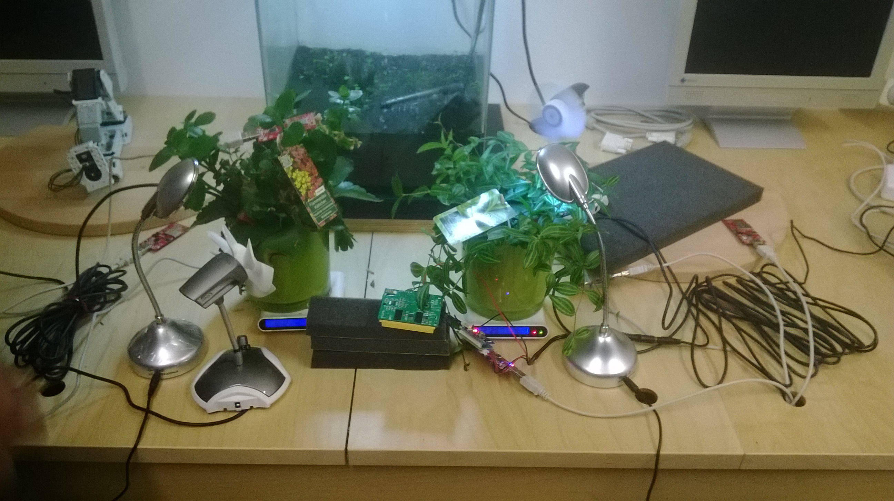

**Chapter - 5 : Formulas for Calculation**

**5.1 Formulas for Light:**

**Formula :**

The Vsensor value must be calculated by first of all obtaining the raw ADC count value of each sensor. This value can vary depending on the microcontroller's configuration. The default TinyOS-2.x configuration assumes the following values for a TelosB platform:

**Vsensor = (ADCvalue/4096) × Vref**

**Vref = 1.5 V**

The S1087 sensors in the EM1000 are connected as follows:

* S1087 ↔ ADC4 (with Calibration OFF)
* S1087 ↔ ADC6 (with Calibration ON)
* S1087-01 ↔ ADC5

The only difference between the calibrated and not calibrated S1087 is the **Vref** value, which is now **2.5 V**, while the S1087-01 suffers no change. The formulas now are as follows:   
**Vsensor = (ADCvalue/4096) × Vref   
ICal = Vsensor / 100,000 = (ADC6value/4096) × 2.5 / 105  
INot Cal = Vsensor / 100,000 = (ADC4value/4096) × 1.5 / 105  
IS1087-01 = Vsensor / 100,000 = (ADC5value/4096) × 1.5 / 105   
  
S1087Cal lx = 0.625 × 106 × ICal × 1000  
S1087Not Cal lx = 0.625 × 106 × INon Cal × 1000  
S1087-01 lx = 0.769 × 105 × IS1087-01**

**Unit :** Lux

* 1. **Formulas for Temperature** :

**Formula:**

temperature = 0.01 \* raw\_temp - 39.6;

Celsius = raw\_temp \* 0.01 - 40

Fahrenheit = raw \_temp \* 0.018 – 40

**Unit :** °C

**5.3 Formulas for Humidity:**

**Formula:**

humidity\_val = (temperature - 25) \* (0.01 + 0.00008 \* raw\_humidity)

- 2.0468 + 0.0367 \* raw\_humidity - 1.5955E-6 \* pow(raw\_humidity, 2);

**Unit :** percent

* 1. **Formulas for Soil Moisture :**

**Formula:**

Most curves can be approximated with linear segments of the form:

**y= mx-b,**

where m is the slope of the line

The VH400's Voltage to VWC curve can be approximated with 4 segments of the form:

**VWC= mV-b**

**m= (VWC2 - VWC1)/(V2-V1)**

After m is determined, the y-axis intercept coefficient b can be found by inserting one of the end points into the equation:

**b= mv-VWC**

|  |  |
| --- | --- |
| Voltage Range | Equation |
| 0 to 1.1V | VWC= 10V-1 |
| 1.1V to 1.3V | VWC= 25V- 17.5 |
| 1.3V  to 1.82V | VWC= 48.08V- 47.5 |
| 1.82V to 2.2V | VWC= 26.32V- 7.89 |

**Unit:** VWC (Volumetric Water Content)

* 1. **Formulas for CO2 :**

**Formula :**

ADC (Vref=2.5V);

V(Raw voltage) is adc\_value/4096\*2.5;

CO2 concentration(ppm) = V(Raw voltage) \* (3000 / 3) – 200

**Unit :** ppm

**Chapter - 6 : Usage of Actuator**

**6.1 Actuator behavior on different condition:**

|  |  |  |  |  |  |
| --- | --- | --- | --- | --- | --- |
| **Peperomia & Kalanchoe Plant** | | | | | |
| **Conditions** | **Actuators** | **Fan** | **Heater** | **Light** | **Remarks** |
|
| Light | below theshold value | - | - | LIGHT ON | Print : LIGHT LOW ! |
| Threshold Value | - | - | LIGHT OFF | Print : LIGHT OK ! |
| above theshold value | - | - | LIGHT OFF | Print : LIGHT HIGH ! |
| CO2 | below theshold value | - | - | - | Print : CO2 LOW ! |
| Threshold Value | FAN OFF | - | - | Print : CO2 OK ! |
| above theshold value | FAN ON | - | - | Print : CO2 HIGH ! |
| Soil moisture | below theshold value | - | - | - | Print : MOSITURE LOW! |
| Threshold Value | - | HEAT OFF | - | Print : MOSITURE OK ! |
| above theshold value | - | HEAT ON | - | Print : MOSITURE HIGH ! |
| Temperature | below theshold value | - | - | - | Print : TEMP LOW ! |
| Value 24-28°C | - | - | - | Print : TEMP OK ! |
| above theshold value | - | - | - | Print : TEMP HIGH ! |
| Air humidity | below theshold value | - | - | - | Print : HUMIDITY LOW ! |
| Threshold Value | - | - | - | Print : HUMIDITY OK ! |
| above theshold value | - | - | - | Print : HUMIDITY HIGH ! |

**Chapter – 7 : Functioning of Application**

**7.1 Functioning of Application:**

**Chapter – 8 : Sampling & Visualization**

**8.1 Sampling & Visualization:**

**Chapter – 9 : Testing & Code Optimization**

**9.1 Testing:**

**9.2 Code Optimization:**

**Chapter – 10 : Challenges**

**10.1 Challenges:**

**Chapter – 11 : Advantages and Disadvantages**

**11.1Advantage of System:**

**11.2 Disadvantage of System:**